**\*= means best slides to use for activity**

**Nostoc\***

Type of algae: Cyanobacteria

*Nostoc* can be found in [soil](https://en.wikipedia.org/wiki/Soil), on moist rocks, at the bottom of lakes and springs (both fresh- and saltwater), and rarely in marine habitats. I

When it is on the ground, a *Nostoc* colony is ordinarily not seen, but after a rain, it swells up into a conspicuous, jellylike mass, which was once thought to have fallen from the sky, hence the popular names, [**star jelly**](https://en.wikipedia.org/wiki/Star_jelly), **troll’s butter**, **witch's butter** (not to be confused with the fungus [*Tremella mesenterica*](https://en.wikipedia.org/wiki/Tremella_mesenterica)), and **witch’s jelly**.

Containing protein and [vitamin C](https://en.wikipedia.org/wiki/Vitamin_C),[[4]](https://en.wikipedia.org/wiki/Nostoc#cite_note-4) *Nostoc* species are cultivated and consumed as a foodstuff, primarily in Asia. The species [*N. flagelliforme*](https://en.wikipedia.org/wiki/Fat_choy)and [*N. commune*](https://en.wikipedia.org/wiki/Nostoc_commune) are consumed in [China](https://en.wikipedia.org/wiki/China), [Japan](https://en.wikipedia.org/wiki/Japan) and [Java](https://en.wikipedia.org/wiki/Java_(island)), *N. commune* is also consumed in the [Andes](https://en.wikipedia.org/wiki/Andes). The preferred variety in [Central Asia](https://en.wikipedia.org/wiki/Central_Asia)is [*N. ellipsosporum*](https://en.wikipedia.org/w/index.php?title=Nostoc_ellipsosporum&action=edit&redlink=1).

Sources: Wikipedia

**Vaucheria\***

Type of algae: yellow-green

*Vaucheria* exhibits apical growth from the tip of filaments forming mats in either terrestrial, freshwater, or brackish water environments.

Sources: Wikipedia, photo from Otago Regional Council and Landcare Research/landcareresearch.co.nz

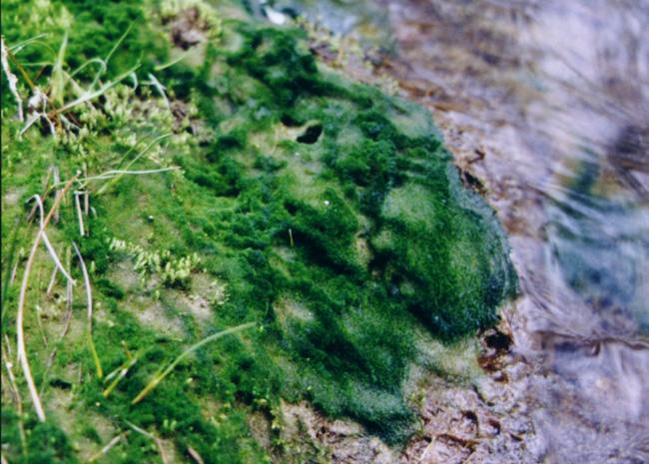

**Oedogonium\***

Type of algae: green algae

*Oedogonium* is a [genus](https://en.wikipedia.org/wiki/Genus) of filamentous [green algae](https://en.wikipedia.org/wiki/Green_algae), with unbranched[[1]](https://en.wikipedia.org/wiki/Oedogonium#cite_note-algaebase-1) filaments that are one cell thick. *Oedogonium* can be [free-floating](https://en.wikipedia.org/wiki/Phytoplankton), though it is usually attached to [aquatic plants](https://en.wikipedia.org/wiki/Aquatic_plant) by a [holdfast](https://en.wikipedia.org/wiki/Holdfast).[[1]](https://en.wikipedia.org/wiki/Oedogonium#cite_note-algaebase-1) It appears greenish and inhabits calm, [fresh water](https://en.wikipedia.org/wiki/Fresh_water).

*Oedogonium* can reproduce asexually by fragmentation of the filaments, through some other types of non-motile spores,[[1]](https://en.wikipedia.org/wiki/Oedogonium#cite_note-algaebase-1) and also through [zoospores](https://en.wikipedia.org/wiki/Zoospore), which have many [flagella](https://en.wikipedia.org/wiki/Flagellum). These develop in its flagella, a zoospore grows into a filament.[[2]](https://en.wikipedia.org/wiki/Oedogonium#cite_note-2)

Sources: Wikipedia

**Spirogyra\***

Type of algae: green algae

*Spirogyra* (common names include water silk, mermaid's tresses, and blanket weed) is a [genus](https://en.wikipedia.org/wiki/Genus) of filamentous [charophyte](https://en.wikipedia.org/wiki/Charophyte) [green algae](https://en.wikipedia.org/wiki/Green_algae) of the [order](https://en.wikipedia.org/wiki/Order_(biology)) [Zygnematales](https://en.wikipedia.org/wiki/Zygnematales), named for the [helical](https://en.wikipedia.org/wiki/Helix) or spiral arrangement of the [chloroplasts](https://en.wikipedia.org/wiki/Chloroplast) that is characteristic of the genus. It is commonly found in [freshwater](https://en.wikipedia.org/wiki/Freshwater) areas, and there are more than 400 species of *Spirogyra* in the world.[[3]](https://en.wikipedia.org/wiki/Spirogyra#cite_note-msu-3) *Spirogyra* measures approximately 10 to 100 [μm](https://en.wikipedia.org/wiki/%CE%9Cm) in width and may grow to several centimeters in length.

*Spirogyra* is very common in relatively clean [eutrophic](https://en.wikipedia.org/wiki/Eutrophic) water, developing slimy filamentous green masses. In spring *Spirogyra* grows under water, but when there is enough sunlight and warmth they produce large amounts of oxygen, adhering as bubbles between the tangled filaments. The filamentous masses come to the surface and become visible as slimy green mats.

Sources: Wikipedia, photo from Britannica/Bob Blaylock

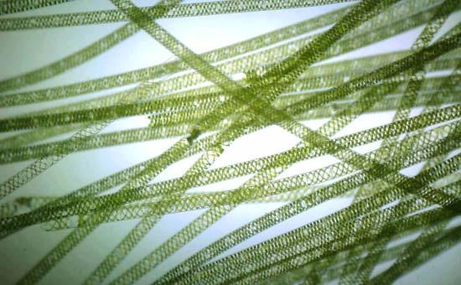

**Volvox\***

Type of algae: green algae

*Volvox* is a [polyphyletic](https://en.wikipedia.org/wiki/Polyphyly) [genus](https://en.wikipedia.org/wiki/Genus) of [chlorophyte](https://en.wikipedia.org/wiki/Chlorophyte) [green algae](https://en.wikipedia.org/wiki/Green_algae) in the family [Volvocaceae](https://en.wikipedia.org/wiki/Volvocaceae). It forms spherical [colonies](https://en.wikipedia.org/wiki/Colony_(biology)) of up to 50,000 cells. They live in a variety of [freshwater](https://en.wikipedia.org/wiki/Freshwater) habitats, and were first reported by [Antonie van Leeuwenhoek](https://en.wikipedia.org/wiki/Antonie_van_Leeuwenhoek) in 1700. *Volvox* diverged from unicellular ancestors approximately [200](http://tools.wmflabs.org/timescale/?Ma=200) million years ago.

*Volvox* is a polyphyletic genus in the volvocine green algae clade.[[2]](https://en.wikipedia.org/wiki/Volvox#cite_note-Kirk-2) Each mature *Volvox* [colony](https://en.wikipedia.org/wiki/Colony_(biology)) is composed of up to thousands of cells from two differentiated cell types: numerous [flagellate](https://en.wikipedia.org/wiki/Flagellate) somatic cells and a smaller number of germ cells lacking in soma that are embedded in the surface of a hollow sphere or [coenobium](https://en.wikipedia.org/wiki/Coenobium_(morphology)) containing an [extracellular matrix](https://en.wikipedia.org/wiki/Extracellular_matrix)[[1]](https://en.wikipedia.org/wiki/Volvox#cite_note-daily-1) made of [glycoproteins](https://en.wikipedia.org/wiki/Glycoprotein).[[3]](https://en.wikipedia.org/wiki/Volvox#cite_note-Hallmann-3) Adult [somatic](https://en.wikipedia.org/wiki/Somatic_cell) cells comprise a single layer with the flagella facing outward. The cells swim in a coordinated fashion, with distinct anterior and posterior poles. The cells have anterior [eyespots](https://en.wikipedia.org/wiki/Eyespot_apparatus) that enable the colony to swim towards light. The cells of colonies in the more basal Euvolvox clade are interconnected by thin strands of [cytoplasm](https://en.wikipedia.org/wiki/Cytoplasm), called protoplasmates.[[4]](https://en.wikipedia.org/wiki/Volvox#cite_note-4) Cell number is specified during development and is dependent on the number of rounds of division.[[2]](https://en.wikipedia.org/wiki/Volvox#cite_note-Kirk-2)

Source: Wikipedia

**Ectocarpus\***

Type of algae: filamentous brown algae

*Ectocarpus* is a [genus](https://en.wikipedia.org/wiki/Genus) of filamentous [brown alga](https://en.wikipedia.org/wiki/Brown_alga) ([Heterokontophyta](https://en.wikipedia.org/wiki/Heterokontophyta)) that is a [model organism](https://en.wikipedia.org/wiki/Model_organism) for the [genomics](https://en.wikipedia.org/wiki/Genomics) of [multicellularity](https://en.wikipedia.org/wiki/Multicellularity). Among possible model organisms in the brown algae, *Ectocarpus* was selected for the relatively small size of its mature thallus and the speed with which it completes its life cycle.[[1]](https://en.wikipedia.org/wiki/Ectocarpus#cite_note-1) The [type species](https://en.wikipedia.org/wiki/Type_species) for the genus is [*Ectocarpus siliculosus*](https://en.wikipedia.org/wiki/Ectocarpus_siliculosus) ([Dillwyn](https://en.wikipedia.org/wiki/Lewis_Weston_Dillwyn)) Lyngbye.

Source: Wikipedia, image from pico plaza/UGent ORCAE (https://bioinformatics.psb.ugent.be/plaza/versions/pico-plaza/organism/view/Ectocarpus+siliculosus)

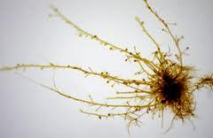

**Mixed Diatoms**

Type of algae: diatom

Diatoms (*diá-tom-os* "cut in half", from *diá*, "through" or "apart"; and the root of *tém-n-ō*, "I cut".) [[10]](https://en.wikipedia.org/wiki/Diatom#cite_note-10) are a major group of [microorganisms](https://en.wikipedia.org/wiki/Microorganisms) found in the oceans, waterways and soils of the world. Living diatoms number in the trillions: they generate about 20 percent of the oxygen produced on the planet each year;[[11]](https://en.wikipedia.org/wiki/Diatom#cite_note-11) take in over 6.7 billion metric tons of [silicon](https://en.wikipedia.org/wiki/Silicon) each year from the oceans in which they live;[[12]](https://en.wikipedia.org/wiki/Diatom#cite_note-12) and contribute nearly half of the organic material found in those oceans.

Diatoms are [unicellular](https://en.wikipedia.org/wiki/Unicellular); they can live alone or form [colonies](https://en.wikipedia.org/wiki/Colony_(biology)), taking shapes such as ribbons, fans, zigzags, and stars. They range in size from 2 to 200 micrometers.[[15]](https://en.wikipedia.org/wiki/Diatom#cite_note-HasleSyvertsen1996-15) In the presence of adequate nutrients and sunlight, an assemblage of living diatoms doubles roughly every 24 hours by [asexual reproduction](https://en.wikipedia.org/wiki/Asexual_reproduction) ([binary fission](https://en.wikipedia.org/wiki/Binary_fission)); their life span, unless they are eaten, is about six days.[[16]](https://en.wikipedia.org/wiki/Diatom#cite_note-16) Diatoms have two shapes: a few (*centric diatoms*) are *radially* symmetric, while most (*pennate diatoms*) approach being *bilaterally* symmetric: this shape is the reason for the group name *diatoms*. A unique feature of diatom [anatomy](https://en.wikipedia.org/wiki/Anatomy) is that they are surrounded by a [cell wall](https://en.wikipedia.org/wiki/Cell_wall) made of [silica](https://en.wikipedia.org/wiki/Silica) (hydrated silicon dioxide), called a [frustule](https://en.wikipedia.org/wiki/Frustule).[[17]](https://en.wikipedia.org/wiki/Diatom#cite_note-17) These frustules have [structural coloration](https://en.wikipedia.org/wiki/Structural_coloration) due to their [photonic](https://en.wikipedia.org/wiki/Photonic) [nanostructure](https://en.wikipedia.org/wiki/Nanostructure), prompting them to be described as "jewels of the sea" and "living opals." Movement primarily occurs passively as a result of both [water currents](https://en.wikipedia.org/wiki/Water_current) and wind-induced water [turbulence](https://en.wikipedia.org/wiki/Turbulance); however, male [gametes](https://en.wikipedia.org/wiki/Gametes) of centric diatoms have [flagella,](https://en.wikipedia.org/wiki/Flagellum) making them capable of active movement. Diatoms convert light energy to chemical energy by [photosynthesis](https://en.wikipedia.org/wiki/Photosynthesis), an attribute they share with [plants](https://en.wikipedia.org/wiki/Plant), although diatoms and plants evolved independently. Diatoms possess a [urea cycle](https://en.wikipedia.org/wiki/Urea_cycle), a feature they share with [animals](https://en.wikipedia.org/wiki/Animal), although it is used differently than in animals.

Diatoms are 2 to 200 micrometers in length.[[15]](https://en.wikipedia.org/wiki/Diatom#cite_note-HasleSyvertsen1996-15) Their yellowish-brown [chloroplasts](https://en.wikipedia.org/wiki/Chloroplast), the site of photosynthesis, are typical of [heterokonts](https://en.wikipedia.org/wiki/Heterokont), having four [membranes](https://en.wikipedia.org/wiki/Plasma_membrane) and containing [pigments](https://en.wikipedia.org/wiki/Biological_pigment) such as the [carotenoid](https://en.wikipedia.org/wiki/Carotenoid) [fucoxanthin](https://en.wikipedia.org/wiki/Fucoxanthin). Individuals usually lack [flagella](https://en.wikipedia.org/wiki/Flagellum), but they are present in male [gametes](https://en.wikipedia.org/wiki/Gamete) of the centric diatoms and have the usual heterokont structure, except they lack the hairs ([mastigonemes](https://en.wikipedia.org/wiki/Mastigonemes)) characteristic in other groups.

Diatoms are often referred as "jewels of the sea" or "living opals" due to their [photonic crystal](https://en.wikipedia.org/wiki/Photonic_crystal) properties.[[18]](https://en.wikipedia.org/wiki/Diatom#cite_note-18) The biological function of this [structural coloration](https://en.wikipedia.org/wiki/Structural_coloration) is not clear, but it is speculated that it may be related to communication, camouflage, thermal exchange and/or UV protection.[[19]](https://en.wikipedia.org/wiki/Diatom#cite_note-19)

Diatoms build intricate hard but porous cell walls (called [frustules](https://en.wikipedia.org/wiki/Frustule) or [tests](https://en.wikipedia.org/wiki/Test_(biology))) composed primarily of [silica](https://en.wikipedia.org/wiki/Silica).[[20]](https://en.wikipedia.org/wiki/Diatom#cite_note-Horner2002-20):25–30 This siliceous wall[[21]](https://en.wikipedia.org/wiki/Diatom#cite_note-CMoG-21) can be highly patterned with a variety of pores, ribs, minute spines, marginal ridges and elevations; all of which can be used to delineate genera and species.

The cell itself consists of two halves, each containing an essentially flat plate, or valve and marginal connecting, or girdle band. One half, the [hypotheca](https://en.wikipedia.org/wiki/Hypotheca), is slightly smaller than the other half, the [epitheca](https://en.wikipedia.org/wiki/Frustule#Thecae). Diatom morphology varies. Although the shape of the cell is typically circular, some cells may be triangular, square, or elliptical. Their distinguishing feature is a hard mineral shell or frustule composed of opal (hydrated, polymerized silicic acid).

Source: Wikipedia

**Laminaria**

Type of algae: brown algae, kelp

*Laminaria* is a [genus](https://en.wikipedia.org/wiki/Genus) of 31 [species](https://en.wikipedia.org/wiki/Species) of [brown algae](https://en.wikipedia.org/wiki/Brown_algae) commonly called "[kelp](https://en.wikipedia.org/wiki/Kelp)". Some species are also referred to as *tangle*. This economically important genus is characterized by long, leathery laminae and relatively large size. Some species are referred to by the common name Devil's apron, due to their shape,[[1]](https://en.wikipedia.org/wiki/Laminaria#cite_note-The_Free_Dictionary2-1) or sea colander, due to the perforations present on the [lamina](https://en.wikipedia.org/wiki/Lamina_(algae)).[[2]](https://en.wikipedia.org/wiki/Laminaria#cite_note-Wellbeing_Being_Well2-2) It is found in the north [Atlantic Ocean](https://en.wikipedia.org/wiki/Atlantic_Ocean) and the northern [Pacific Ocean](https://en.wikipedia.org/wiki/Pacific_Ocean) at depths from 8 to 30 m (26 to 98 ft) (exceptionally to 120 m (390 ft) in the warmer waters of the [Mediterranean Sea](https://en.wikipedia.org/wiki/Mediterranean_Sea)and off [Brazil](https://en.wikipedia.org/wiki/Brazil)).[[3]](https://en.wikipedia.org/wiki/Laminaria#cite_note-:12-3) Laminaria form a habitat for many fish and invertebrates. [[4]](https://en.wikipedia.org/wiki/Laminaria#cite_note-4)

*Laminaria* is found in colder ocean waters, such as arctic regions.[[10]](https://en.wikipedia.org/wiki/Laminaria#cite_note-10) Preferring to say in regions where there are rocky shores, this allows the l*aminaria* to attach. Due to the height of the l*aminaria*, they provide protection for creatures that the open ocean does not often give. Invertebrates are just one of the organisms that live among the algae. Sea snails and other invertebrates feed on the blades (leaves) of the l*aminaria*. Other organisms like sea urchins feed on the holdfasts which end up killing the algae.[[11]](https://en.wikipedia.org/wiki/Laminaria#cite_note-11) [red sea urchins](https://en.wikipedia.org/wiki/Red_sea_urchin), found on the North America Pacific Coast, can decimate kelp, like *Laminaria,* if the urchins are not managed by [sea otters](https://en.wikipedia.org/wiki/Sea_otter).

Source: Wikipedia, photo from [Laminariasetchellii.jpg](https://commons.wikimedia.org/wiki/File:Laminariasetchellii.jpg)

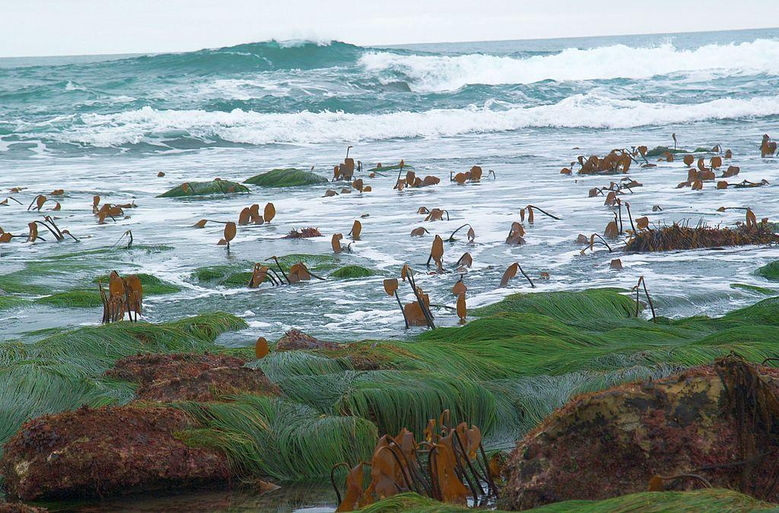

**Porphyra**

Type of algae: red algae, seaweed

*Porphyra* is a coldwater [seaweed](https://en.wikipedia.org/wiki/Seaweed) that grows in cold, shallow [seawater](https://en.wikipedia.org/wiki/Seawater). More specifically, it belongs to [red algae](https://en.wikipedia.org/wiki/Red_algae) phylum of [laver](https://en.wikipedia.org/wiki/Laver_(seaweed)) species, comprising approximately 70 species.[[2]](https://en.wikipedia.org/wiki/Porphyra#cite_note-Brodie_02-2) It grows in the [intertidal zone](https://en.wikipedia.org/wiki/Intertidal_zone), typically between the upper intertidal zone and the splash zone in cold waters of temperate oceans. In East Asia, it is used to produce the [sea vegetable](https://en.wikipedia.org/wiki/Seaweed) products [*nori*](https://en.wikipedia.org/wiki/Nori) (in Japan) and [*gim*](https://en.wikipedia.org/wiki/Gim_(food)) (in Korea). There are considered to be 60 to 70 species of *Porphyra* worldwide[[3]](https://en.wikipedia.org/wiki/Porphyra#cite_note-Kain_91-3) and seven in the British Isles where it has been traditionally used to produce edible sea vegetables on the Irish Sea coast.[[4]](https://en.wikipedia.org/wiki/Porphyra#cite_note-Hardy_and_Guiry_06-4)

Most human cultures with access to *Porphyra* use it as a food or somehow in the diet, making it perhaps the most domesticated of the marine algae,[[8]](https://en.wikipedia.org/wiki/Porphyra#cite_note-Mumford_88-8) known as [laver](https://en.wikipedia.org/wiki/Laver_(seaweed)), [*nori*](https://en.wikipedia.org/wiki/Nori) ([Japanese](https://en.wikipedia.org/wiki/Japanese_language)), *amanori* (Japanese),[[9]](https://en.wikipedia.org/wiki/Porphyra#cite_note-Abbott-9) *zakai*, [*gim*](https://en.wikipedia.org/wiki/Gim_(food)) ([Korean](https://en.wikipedia.org/wiki/Korean_language)),[[9]](https://en.wikipedia.org/wiki/Porphyra#cite_note-Abbott-9) *zicai* ([Chinese](https://en.wikipedia.org/wiki/Standard_Chinese)),[[9]](https://en.wikipedia.org/wiki/Porphyra#cite_note-Abbott-9) [karengo](https://en.wikipedia.org/wiki/Pyropia_columbina), *sloke* or *slukos*.[[3]](https://en.wikipedia.org/wiki/Porphyra#cite_note-Kain_91-3) The marine red alga *Porphyra* has been cultivated extensively in many [Asian](https://en.wikipedia.org/wiki/Asia) countries as an [edible seaweed](https://en.wikipedia.org/wiki/Edible_seaweed) used to wrap the rice and fish that compose the Japanese food [sushi](https://en.wikipedia.org/wiki/Sushi), and the Korean food [*gimbap*](https://en.wikipedia.org/wiki/Gimbap). In Japan, the annual production of *Porphyra* species is valued at 100 billion [yen](https://en.wikipedia.org/wiki/Japanese_yen) (US$1 billion).[[10]](https://en.wikipedia.org/wiki/Porphyra#cite_note-Aoki_06-10)

Source: Wikipedia , photo from Gabriele Kothe-Heinrich

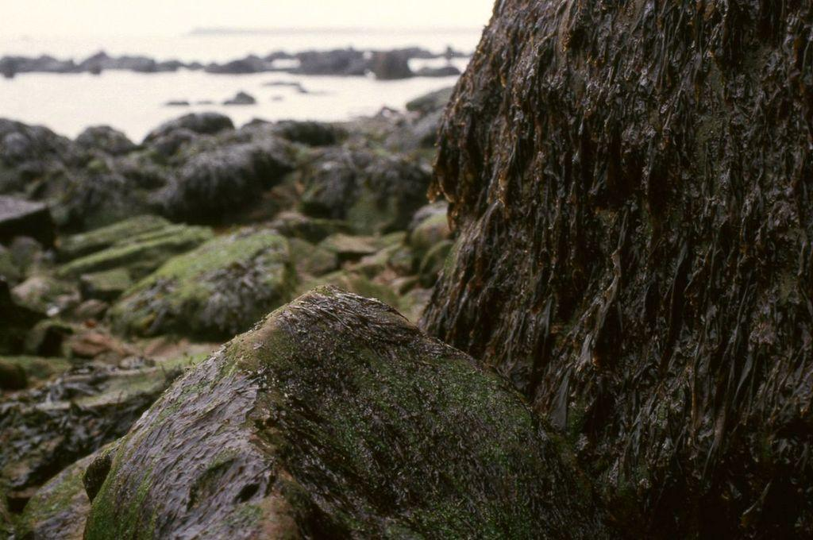

Desmids

Type of algae: green algae

The structure of these [algae](https://en.wikipedia.org/wiki/Algae) is [unicellular](https://en.wikipedia.org/wiki/Cell_(biology)), and lacks [flagella](https://en.wikipedia.org/wiki/Flagella). Although most desmids are unicellular, the species *Desmidium swartzii* forms chains of cells resembling the [algae](https://en.wikipedia.org/wiki/Filamentous_algae) genus [*Spirogyra*](https://en.wikipedia.org/wiki/Spirogyra). However, these filaments are arranged in a helix pattern.[[7]](https://en.wikipedia.org/wiki/Desmidiales#cite_note-microscopy-uk.org.uk-7)

The cell of a desmid is often divided into two [symmetrical](https://en.wikipedia.org/wiki/Symmetry_in_biology) [compartments](https://en.wikipedia.org/wiki/Cellular_compartment) separated by a narrow bridge or isthmus, wherein the spherical nucleus is located. Each semi-cell houses a large, often folded [chloroplast](https://en.wikipedia.org/wiki/Chloroplast) for [photosynthesizing](https://en.wikipedia.org/wiki/Photosynthesis). One or more [pyrenoids](https://en.wikipedia.org/wiki/Pyrenoid) can be found. These form carbohydrates for energy storage. The cell-wall, of two halves (termed semicells), which, in a few species of *Closterium* and *Penium*, are of more than one piece, has two distinct layers, the inner composed mainly of cellulose, the outer is stronger and thicker, often furnished with spines, granules, warts et cetera. It is made up of a base of cellulose impregnated with other substances including iron compounds, which are especially prominent in some species of *Closterium*and *Penium* and is not soluble in an ammoniacal solution of copper oxide.

Desmids assume a variety of highly [symmetrical](https://en.wikipedia.org/wiki/Symmetry) and generally attractive shapes, among those elongated, star-shaped and rotund configurations, which provide the basis for their classification.[[7]](https://en.wikipedia.org/wiki/Desmidiales#cite_note-microscopy-uk.org.uk-7) The largest among them may be visible to the unaided eye.[[8]](https://en.wikipedia.org/wiki/Desmidiales#cite_note-desmids.com-8)

Desmids possess characteristic [crystals](https://en.wikipedia.org/wiki/Crystal) of [barium sulphate](https://en.wikipedia.org/wiki/Barium_sulphate) at either end of the cell[[9]](https://en.wikipedia.org/wiki/Desmidiales#cite_note-9) which exhibit a continuous [Brownian](https://en.wikipedia.org/wiki/Brownian_motion) type motion.[[*clarification needed*](https://en.wikipedia.org/wiki/Wikipedia:Please_clarify)]

Many desmids also secrete translucent, [gelatinous](https://en.wikipedia.org/wiki/Gelatinous) mucilage from pores in the cell wall that acts a protecting agent. These pores are either, as in Micrasterias, uniformly distributed across the cell-wall but always appear to be absent in the region of the isthmus, or, in highly ornamented forms, as many genera of Cosmarium, grouped symmetrically around the bases of the spines, warts and so on with which the cell is provided.

In the inner layer of the wall the pore is a simple canal, but in the outer, except in Closterium, the canal is surrounded by a specially differentiated cylindrical zone, not composed of cellulose, through which the canal passes. This is termed the pore-organ. The canals are no doubt in all cases occupied by threads of mucilage in process of excretion. At the inner surface of the wall they terminate in lens- or button-shaped swellings, while from the outer end of the pore-organ there sometimes arise delicate radiating or club-shaped masses of mucilage through which the canal passes and which appear to be more or less permanent in character. In most cases, however, these are absent or only represented by small perforated buttons.

Source : Wikipedia